1. Breadth First Search (BFS)
Aim
To implement the Breadth First Search (BFS) algorithm using Python.
Objective
- To traverse all the vertices of a graph level by level.
- To understand queue-based graph traversal.
- To visit every reachable node exactly once.
Algorithm
- Start from the source vertex.
- Mark the source as visited.
- Insert the source into a queue.
- While the queue is not empty:
  - Remove the front vertex.
  - Print the vertex.
  - Visit all its adjacent vertices.
  - If an adjacent vertex is not visited:
    - Mark it as visited.
    - Add it to the queue.
- Stop when the queue becomes empty.
Flow Chart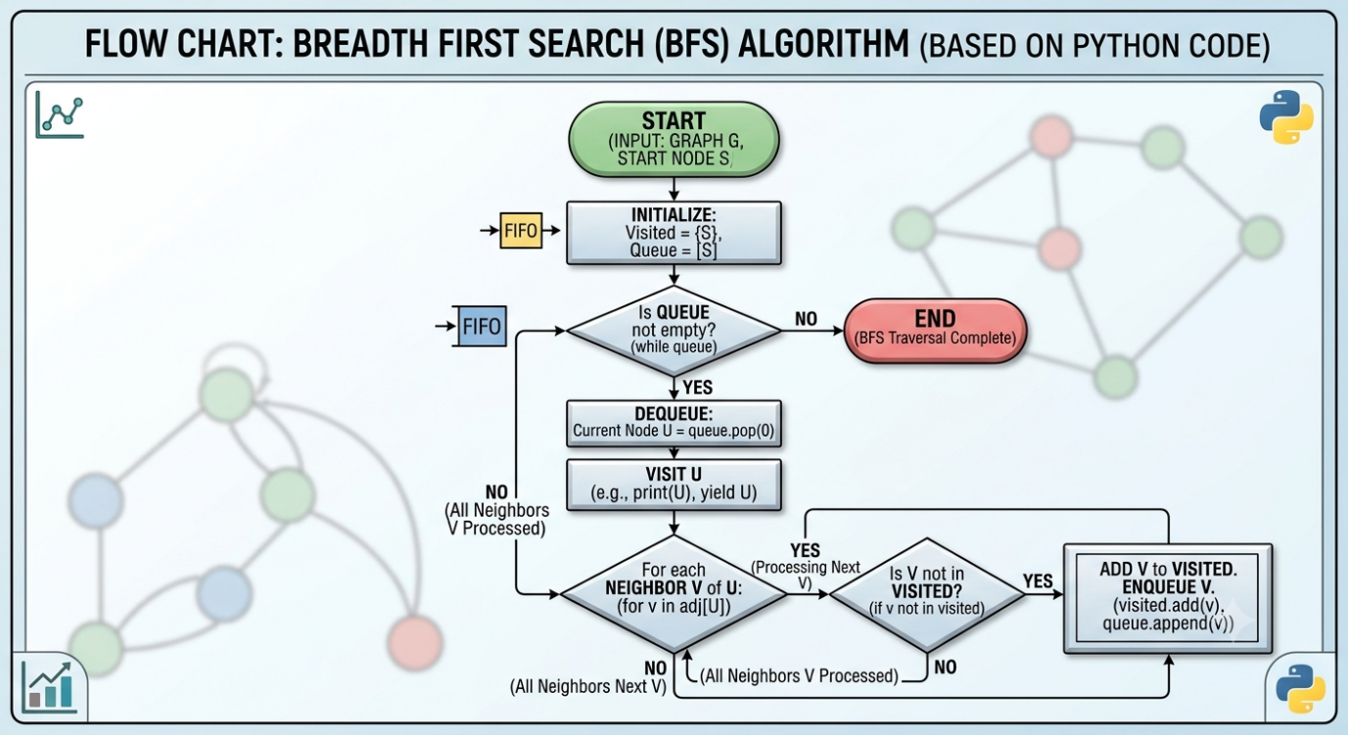

from collections import deque
Python Code
graph = {
'A': ['B', 'C'],
'B': ['D', 'E'],
'C': ['F'],
'D': [],
'E': ['F'],
'F': []
}

visited = set()

def bfs(start):
queue = deque([start])
visited.add(start)

while queue:
vertex = queue.popleft()
print(vertex, end=" ")

for neighbor in graph[vertex]:
if neighbor not in visited:
visited.add(neighbor)
queue.append(neighbor)

print("BFS Traversal:")
bfs('A')
Result:
